The regular meeting of the Oneonta Town Board was held on February 08, 2023 @07:00PM, with the following members present:

Town Board Member: Patricia Riddell Kent (PRK)
Town Board Member: Brett Holleran (BH)
Town Board Member: Kim Fierke (KF)
Town Board Member: Skylar J. Thompson (SJT)
Supervisor: Randal I. Mowers (RM)
Town Clerk: Ryan F. Pereira (RFP)
Town Attorney: Robert Panasci (RP)

Others present: James A. Hurtubise II, Superintendent of Highways; Tom Rowe; Korey Rowe; Theresa Cyzeski; David Cyzeski; Wiliam Weinhart; Teresa DeSantis; Jim Rowe; Dan Baker; Dale Webster; Dave Webster; Breck Tarbell; Frank Russo; Diane Russo; Steve Kent.

Petitioners: “Privilege of the floor.”

- Korey Rowe spoke concerning limitations the Town Board may put onto the allowance of Cannabis based businesses to operate within the Town of Oneonta with a proposed Local Law, “Cannabis Retail Dispensary Law of the Town of Oneonta”, recommending patience instead, and await guidance from the State. Mr. Rowe's full statement is on file in the Clerk's office.
- William Weinhart spoke in support of allowing time for the State to finalize legislation/enforcement, for the handling of Cannabis businesses within the Town.

RESOLUTION 2023-030 Motion made by Thompson, seconded by Mowers;
WHEREAS; authorize the expenditure of budgeted funds for a Cam Superline 25 Ton Deck Over Equipment Trailer;
WHEREAS; quotes from three vendors submitted:

Trailers LLC $41637.00
Tracy Road Equip. $48932.00
Clinton Tractor $53950.00

RESOLVED; the lowest of three quotes shall be accepted according to Town purchasing guidelines; NOW THEREFORE BE IT RESOLVED; that the Town Board of Oneonta approves the purchase of a Cam Superline 25 Ton Deck Over Equipment Trailer, from the lowest bidder, Trailers LLC.
VOTE Aye (5) SJT RM MOTION CARRIED

RESOLUTION 2023-031 Motion made by Holleran, seconded by Thompson;
WHEREAS; Board authorization of Barton & Loguidice to prepare Map Plan and Report for review East End Water & Sewer District;
RESOLVED; authorization of funds up to $35,000 to be expended in the preparation of such;
NOW THEREFORE BE IT RESOLVED; that the Town Board of Oneonta approves the expenditure of funds in the preparation of a Map Plan and Report for review from Barton & Loguidice for a proposed East End Water & Sewer District.
VOTE Aye (4) Nay (1) PRK BH SJT MOTION CARRIED

Board Member Riddell Kent: “…since residents and small businesses in the East End are not interested in water and sewer services…, IF the engineering findings recommend mandatory hook up for small businesses and residential properties for grant funding to be obtained, I would not be able to support the project. For these reasons, I vote no.”
PRK asked if the IDA or either of the 2 large commercial properties wanting water & sewer services have agreed to chip in on the engineering cost to the Town. PRK acknowledged that Supervisor Mowers has been communicating with these businesses.

RESOLUTION 2022-032 Motion made by Riddell Kent, seconded by Fierke;
WHEREAS; NOW THEREFORE BE IT RESOLVED the Town Board will set PUBLIC HEARING for March 08, 2023; Local Law#1, “Cannabis Retail Dispensary Law of the Town of Oneonta.”
VOTE Aye (5) PRK KF MOTION CARRIED

RESOLUTION 2023-033 Motion made by Riddell Kent, seconded by Thompson;
WHEREAS; the Town Board shall approve the hire of a new FIRE INSPECTOR;
NOW THEREFORE BE IT RESOLVED; NEIL FOGHERTY is appointed to the position of FIRE INSPECTOR, with the hire date of February 07, 2023.
VOTE Aye (5) PRK SJT MOTION CARRIED

RESOLUTION 2023-034 Motion made by Thompson, seconded by Riddell Kent;
WHEREAS; the day for the grievance of taxes before the Board of Assessment Review [BAR];
WHEREAS; the Town Board shall change the date of the day for grievance of taxes at the recommendation of the Tax Assessor;
NOW THEREFORE BE IT RESOLVED; the day for the grievance of taxes before the BAR, shall be held on the “Tuesday after the Fourth Tuesday of May.” [TAFTOM]
VOTE Aye (5) SJT PRK MOTION CARRIED
RESOLUTION 2023-035 Motion made by Thompson, seconded by Holleran;
WHEREAS; NOW THEREFORE BE IT RESOLVED; the Town Board approves payment of the bills.
VOTE Aye (5) SJT BH MOTION CARRIED

RESOLUTION 2023-036 Motion made by Fierke, seconded by Riddell Kent;
WHEREAS; NOW THEREFORE BE IT RESOLVED; the Town Board shall accept the Minutes of the January 11th meeting.
VOTE Aye (5) KF PRK MOTION CARRIED

RESOLUTION 2023-037 Motion made by Riddell Kent, seconded by Thompson;
WHEREAS; Adjournment for the February 08,2023 meeting;
NOW THEREFORE BE IT RESOLVED; meeting adjourned @07:50PM.
VOTE Aye (5) PRK SJT MOTION CARRIED

Respectfully submitted,
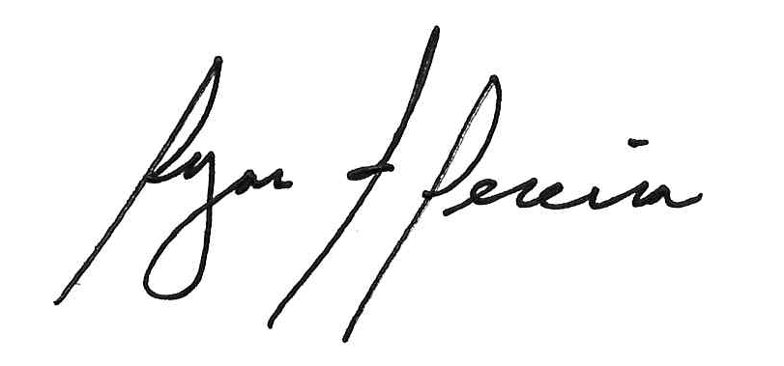
Ryan F. Pereira
Town Clerk

