The regular meeting of the Oneonta Town Board was held on August 9, 2023, with the following members present:

Town Board Member: Kim Fierke
Town Board Member: Skylar J. Thompson (absent)
Town Board Member: Patricia Riddell Kent (absent)
Supervisor: Randal I. Mowers
Town Board Member: Brett Holleran
Town Clerk: Ryan F. Pereira
Town Attorney: Robert Panasci

Others present: James A. Hurtubise, Supt. of Highways; Michele Catan, County Rep.; Emily, Sue and Dave Morell; Marjorie and William Pietraface; Barbara and Douglas Bush; Michael Schmitt; Tom Armao; Richard Harlem; Dave Rowley; Ron Bettiol; Andrea Lister; Joe and Nicole Camarata; Theresa Cyzeski.

Presentation

Emily Morrell, Girl Scout Gold Award recipient, presented a slideshow to the Board of the completed renovation project, in which additions and improvements were made to the Town Pool.

Petitioners “Privilege of the floor”

Jim Devins brought forth grievances concerning parking issues at the intersection of Shepard Ave. And Orchard Ave.; sighting vehicles parking in “NO PARKING” zones creating difficulties for traffic making turns at the intersection.

Marjorie and William Pietraface, Barbara and Douglas Bush; being residents of Plains at Parish have concerns over water rates assessed them and their neighbors. Mr. Bush presented the Board members with a series of questions he would like answered. Superintendent Hurtubise agreed to investigate the matter further, in time for the next Highway/Water committee meeting. Supervisor read aloud the following statement: “In regard to the 2023 water bills for Plains of Parish residents. We were aware that there are a few residents with higher bills than in previous years, but there are also a normal number of residents that had very consistent usage and bills. The residents with issues may have a longer billing period, 15 months as opposed to 12 months, along with a rate increase to cover the increased water bill from the City of Oneonta. The town has re-read the meters of all residents with higher bills, those having made the town aware of it. We tested three meters for the residents with the highest usage and all were found to be accurate. The water usage was also examined and found to be within normal range. Over half the bills for the district have already been paid. And at this point, we have no intention of adjusting the rate or reducing the usage bill without evidence of faulty metering. We understand this is a small district and we will be looking more closely into ways to reduce rates for the 2024 billing period. Any further discussion will be addressed at the Highway/Water committee meeting next month.”

Highway, Water & Sewer

Discussions for the formation of a “West End Water District”; from West End Ave., down Chestnut St. and Oneida St., all points in between, have begun with the city, the city owning the water infrastructure, and the town owning the sewer.

Facilities, Technology & Parks

A solar powered light has been installed by the Supervisor and the Town Clerk on the flagpole outside the Town Hall to provide lighting for the flag at night.

Legislative

B-2 Considerations are being considered for the 205/23 corridor.

Code Enforcement

Ken Baines was present to explain to the Board work was underway to clean up his yard, and address neighbors' concerns.

RESOLUTION 2023-067 (19:45) Motion made by Fierke, seconded by Holleran;
Whereas the Board will vote to set public hearing to convert tax map parcel number 289.00-1-65.00, from residential to commercial, R10 into a B2; now, therefore be it
Resolved, that the Board shall set said hearing for public comment on September 13, 2023, the date of the following Town Board meeting.

VOTE Aye (3) KF BH MOTION CARRIED

RESOLUTION 2023-068 (19:50) Motion made by Fierke, seconded by Holleran;
Whereas the Town Board shall adopt a resolution in opposition to NYS Senate Bill S-00139B and Assembly Bill A-1358B;
TOWN of ONEONTA, NEW YORK
RESOLUTION IN OPPOSITION TO NEW YORK STATE SENATE BILL S-00139B and ASSEMBLY BILL A-1358B
WHEREAS, New York Senate Bill number S-00139B has been passed which, if adopted by the NYS Assembly (A 1358-B) and signed by the Governor, would require all Judges presiding in the 100 largest Town and Village Courts to be licensed to practice law in the State and to have been admitted to the NYS Bar for at least five years; and
WHEREAS, The Town and Village Courts in OTSEGO County are among the nearly 1,200 Justice Courts in the State of New York that collectively handle close to 1 million cases each year; and
WHEREAS, The Town and Village Courts are known as the “Courts Closest to the People” and have broad jurisdiction, presiding over civil and criminal matters, thereby performing a vital role in the New York State Unified Court System; and
WHEREAS, The Town/Village Court of ONEONTA is a vital service to our residents and the OTSEGO County community as a whole; and
WHEREAS, The Justices in OTSEGO County’s Town and Village Courts have pledged to be ever mindful of their neutrality and impartiality, and render equal justice to all, while continually adhering to judicial rules of ethics and pronouncements of the New York State Commission on Judicial Conduct; and
WHEREAS, The Justices are required to be on-call 24 hours a day, 365 days a year to review/sign arrest and search warrants, perform arraignments, and issue orders of protection; and
WHEREAS, The Justices of Town and Village Courts ensure that the rights afforded to defendants by the Constitutions of the United States and the State of New York are provided and protected; and
WHEREAS, The Justices of Town and Village Courts preside over trials involving misdemeanor and violation level offenses, thereby ensuring that the victims of those offenses can be heard; and
WHEREAS, The Town and Village Courts provide a venue for Citizens to pursue a low-cost and efficient procedure for individuals to resolve civil disputes and landlord/tenant matters; and
WHEREAS, The Justices preside nightly and weekend and holiday mornings at the OTSEGO County Arraignment Part (‘CAP’) conducted in the County Jail, (CAP) that ensures that arrested citizens are promptly afforded legal representation, the opportunity to plead to alleged charges, and be processed for release, bail, or incarceration; and
WHEREAS, The Justices continually strive to improve the administration of justice through participation in mandatory education programs, seminars, meetings of the OTSEGO County Magistrates Association and the New York State Magistrates Association; and
WHEREAS, The New York State Office of Court Administration must certify all as having successfully completed mandatory training both following election and in each subsequent year; and
WHEREAS, The New York State’s Commission on Judicial Conduct’s most recent annual report (2023) identifies that only 13% of the complaints filed against the judiciary were against Town and Village judges while the remaining complaints were against either “State-paid” judges, (constituting approximately 40% of the judiciary) who accounted for approximately 67% of the complaints received, or against non-judicial entities (20%); and
WHEREAS, This Bill attempts to usurp the right of voters to elect those in their communities that they believe to be fair and impartial, and who would best serve that community, whether they be attorneys or non-attorneys; and
WHEREAS, This Bill implicitly suggests that members of a community are incapable of making informed decisions about who should sit in judgment of matters from the straight-forward to the highly complex as may arise in their local courts; and
WHEREAS, this legislative body views the intention of this Bill is not to actually improve the courts, but a blatant and unconscionable attempt by the New York State Bar Association, an organization that represents approximately only fifteen percent (15%) of the State’s attorneys, to generate increased opportunities for its members, and to dictate who voters may choose to serve in our local governments;
NOW THEREFORE, BE IT RESOLVED, That the Governing board of the Town/Village of ONEONTA strongly, and in unequivocal terms, calls on both the leadership in the Senate and Assembly, and the Governor to reject this poorly conceived and hastily fashioned seizure of voters’ rights to determine, for themselves, who they would choose to sit as their judges as has been the case for almost two hundred years.
Adopted by unanimous consent this 9th day of AUGUST, 2023.

VOTE Aye (3) KF BH MOTION CARRIED

Michelle Catan updated the Board on the County’s ongoing issues of homelessness and displaced individuals; most recently Motel 88, on Chestnut St., had become the center of one such expansion of housing opportunities made available. With the expenditure of over 650k dollars by the County for the one property, an 18-month period, drew questions from audience members, and safety concerns about the surrounding neighborhoods, as well as the lack of a long-term vision to better mitigate and manage a seemingly unending stream of displaced persons into the area. The County is on track to spend annually approximately two million dollars towards efforts, both short and long-term.

RESOLUTION 2023-069 (20:08) Motion made by Fierke, seconded by Holleran;
Whereas now, therefore, be it resolved; the Town Board approves the payment of the bills.

VOTE Aye (3) KF BH MOTION CARRIED

RESOLUTION 2023-070 (20:09) Motion made by Fierke, seconded by Holleran;
Whereas now, therefore, be it resolved; the Town Board shall accept the Minutes of the July 12th meeting.

VOTE Aye (3) KF BH MOTION CARRIED

RESOLUTION 2023-071 (20:10) Motion made by Fierke, seconded by Holleran;
Whereas now, therefore, be it resolved; the Town Board meeting be adjourned.

VOTE Aye (3) KF BH MOTION CARRIED

Respectfully submitted,
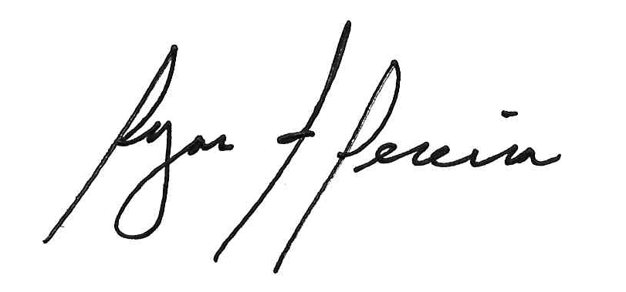
Ryan F. Pereira
Town Clerk

