The regular meeting of the Oneonta Town Board was held on January 11th, 2023 @07:00PM, with the following members present:

Town Board Member: Kim Fierke (KF)
Town Board Member: Skylar J. Thompson (SJT)
Town Board Member: Patricia Riddell Kent (PRK)
Town Board Member: Brett Holleran (BH)
Supervisor: Randal I. Mowers (RM)
Town Clerk: Ryan F. Pereira (RFP)
Town Attorney: Robert Panasci (RP)

Others present: James A. Hurtubise II, Superintendent of Highways; Walter P. Schmitt Jr.; Michael Schmitt; Bill Ellis; Vicky Klukkert, The Daily Star; Tom Rowe; Jim Rowe; Dale Webster; Kathy Verrelli; Jim Verrelli; Theresa Cyzeski; Thom Trelease; Steve Kent.

Petitioners: “Privilege of the floor.”

- Thom Trelease, a volunteer with Trout Unlimited (TU); asked the Board whether (TU) may be granted permission to repair a wooden structure (dock/platform) located in Fortin Park, at the junction of the Charlotte Creek and the Susquehanna River; which serves as sitting area, as well as, a place from which to fish.
- Theresa Cyzeski; read-aloud a statement voicing concerns, and a call for accountability, and collaboration from local government officials. The two main points of Mrs. Cyzeski’s statement centered on recent Board appointments, and pay raises for Town employees. The statement will be filed in the Town Clerk’s office.

RESOLUTION 2023-019 Motion made by Holleran, seconded by Riddell Kent;
WHEREAS; Board approval of emergency repairs for the dock/platform at the confluence of the Susquehanna River, and the Charlotte Creek, to be done by Trout Unlimited.
VOTE- Aye (5) SJT BH MOTION CARRIED

RESOLUTION 2022-020 Motion made by Fierke, seconded by Riddell Kent;
WHEREAS; PUBLIC HEARING OPEN, Local Law#1, “Cannabis Retail Dispensary Law of the Town of Oneonta.”
VOTE- Aye (5) KF PRK MOTION CARRIED
Discussions ranged from the legal, and illegal nature of the sale of marijuana, as well as, the current state of the Cannabis Law in New York State; as with regards to Local Law #1, and how the Town of Oneonta plans to establish an overlay district.

RESOLUTION 2023-021 Motion made by Riddell Kent, seconded by Thompson;
WHEREAS; PUBLIC HEARING CLOSED, Decision on the law was tabled, barring any major revisions to the law, a decision will be made February 8th ,2023. Should revisions weight beyond what is permissible, a new Public Hearing must be set.
VOTE- Aye (5) PRK SJT MOTION CARRIED

RESOLUTION 2023-022 Motion made by Fierke, seconded by Riddell Kent;
WHEREAS; purchase of a ROOT GRAPPLE bucket for skid steer approved at no more than $2650.00.
VOTE- Aye (5) KF PRK MOTION CARRIED
RESOLUTION 2023-023 Motion made by Holleran, seconded by Thompson;
WHEREAS; Thom Trelease will be stepping down as alternate to the Zoning Board of Appeals (ZBA),
WHEREAS; John B. Leahy appointed to serve as alternate to the ZBA, to serve out the remainder of the post left by Thom Trelease.
VOTE- Aye (3) Nay (2) (PRK, KF) BH SJT MOTION CARRIED
Dissent from naysayers extended from comments exchanged at the Organizational Meeting surrounding appointments to the ZBA. Board Member Riddell Kent stated, “I think John would be a very good choice for ZBA alternate, however a ZBA member is willing to be reappointed to serve again. For this reason, I am voting no.”

RESOLUTION 2023-024 Motion made by Thompson, seconded by Fierke;
WHEREAS; permission requested to expend budgeted funds for line items A3620.4: a. NFPA Membership renewal $175.00, b. NFPA Link renewal $130.00, c. STBOA Membership renewal $40.00.
VOTE- Aye (5) SJT KF MOTION CARRIED

RESOLUTION 2023-025 Motion made by Thompson, seconded by Holleran;
WHEREAS; permission requested to expend budgeted funds for line items A3620.2: a. approval to order printer, not to exceed $500.00, b. approval to order laptop, not to exceed $1500.00.
VOTE- Aye (5) SJT BH MOTION CARRIED

RESOLUTION 2023-026 Motion made by Thompson, seconded by Holleran;
WHEREAS; approval of contractual services provided by the County for Tax Assessment services.
VOTE- Aye (5) SJT BH MOTION CARRIED

RESOLUTION 2023-027 Motion made by Riddell Kent, seconded by Fierke;
WHEREAS; to approve payment of the bills.
VOTE- Aye (5) PRK KF MOTION CARRIED

RESOLUTION 2023-028 Motion made by Riddell Kent, seconded by Fierke;
WHEREAS; to accept the Minutes of the December 14th ,2023 meeting.
VOTE- Aye (5) PRK KF MOTION CARRIED

RESOLUTION 2023-029 Motion made by Thompson, seconded by Fierke;
WHEREAS; Adjournment for the January 11th ,2023 meeting;
NOW, therefore be it resolved; meeting adjourned @08:25PM.
VOTE- Aye (5) SJT KF MOTION CARRIED

Respectfully submitted,
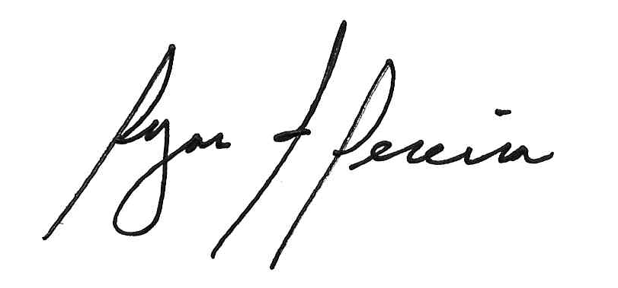
Ryan F. Pereira
Town Clerk

